💰
PERSONAL FINANCE ADVISOR BOT
📘 PROJECT DOCUMENTATION

👩‍🎓 Student | Aishwarya Pramod Patil
🏫 Department | Artificial Intelligence - Machine Learning
📅 Academic Year | 2026–2027

💡 A practical web application for managing income, expenses, budgets, savings, analytics and AI-powered educational financial guidance.

1. Abstract
Personal Finance Advisor Bot is a web-based application designed to help users manage income, expenses, budgets and savings in one place. It provides financial summaries, charts and an AI chatbot for educational financial guidance. The system combines a simple user interface with Flask, SQLite and Gemini AI to provide an interactive and practical personal finance management experience.

Introduction
Managing personal finances can be difficult when income and daily expenses are not properly tracked. This application provides a simple digital platform where users can record transactions, monitor budgets, understand spending patterns and receive basic AI-powered financial guidance.

3. Problem Statement
Students and individuals often find it difficult to track income, expenses, savings and monthly budgets. A simple, interactive and beginner-friendly application is required to organize financial information and provide useful spending insights.

4. Objectives
- Record and categorize income and expenses.
- Calculate balance, savings and budget usage.
- Display financial information through charts and summaries.
- Provide AI-based educational financial guidance.
- Create a simple, responsive and user-friendly web application.

5. System Flow / Architecture
The user interacts with the web interface. Requests are handled by Flask REST APIs, validated through the business logic, and stored in SQLite. The chatbot communicates with the Gemini API through the backend.
👤 USER | → | 🌐 HTML/CSS/JavaScript | → | ⚙️ FLASK REST API
 | → | 🧠 BUSINESS LOGIC | → | 🗄️ SQLITE DATABASE
 |  | ↘ |  | 🤖 GEMINI AI SERVICE → 💬 AI RESPONSE

Tools & Technologies Used

Category | Technology
🖥️ Frontend | HTML5, CSS3, JavaScript
⚙️ Backend | Python, Flask
🗄️ Database | SQLite, Flask-SQLAlchemy
🤖 AI | Google Gemini API
📊 Charts | Chart.js
🔌 API | REST API, Fetch API
🛠️ Development | VS Code / Antigravity
🌐 Version Control | Git & GitHub

7. Main Modules
- Dashboard – income, expenses, balance, savings and recent transactions.
- Income & Expense – add and manage financial transactions.
- Transactions – view, search, filter, edit and delete records.
- Budget – set monthly budget and monitor remaining amount.
- Analytics – view spending categories, income and expense trends.
- AI Chatbot – receive educational guidance on budgeting and saving.

8. Development Process
- Created project structure and virtual environment
- Developed Flask backend and database
- Implemented transaction and budget APIs
- Built responsive frontend
- Added analytics and chart
- Integrated Gemini chatbot
- Added validation and error handling
- Tested the complete application
- Prepared documentation and GitHub repository

9. Web Application Interface
The following screenshots show the implemented and working web application
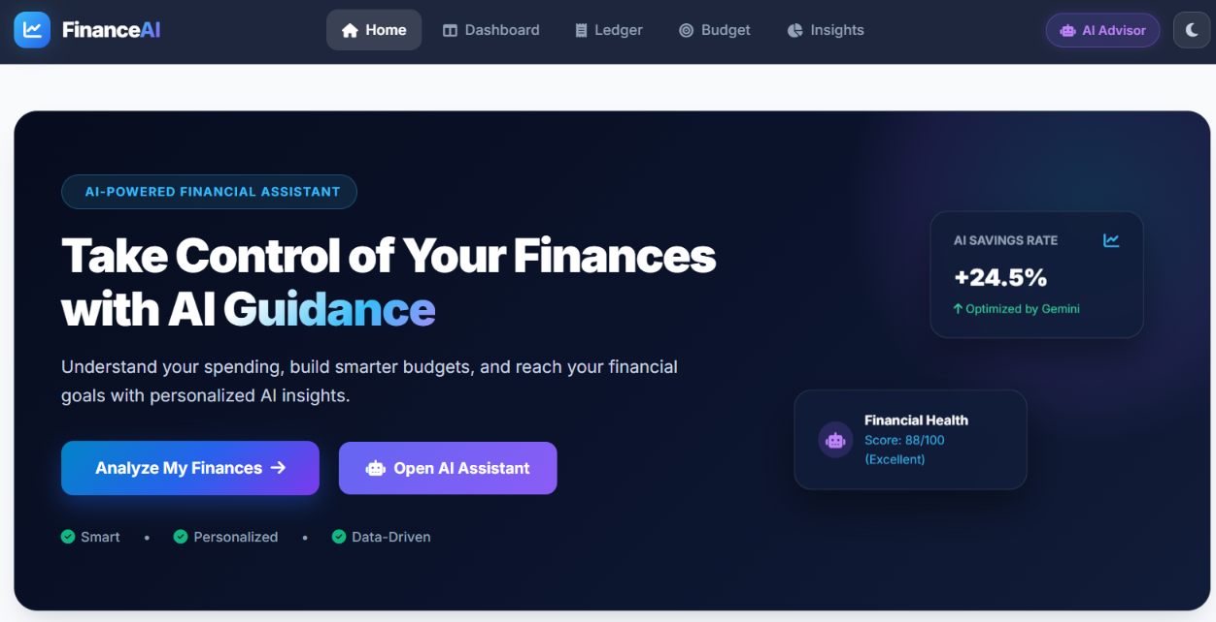
Figure 1: Home / Landing Page

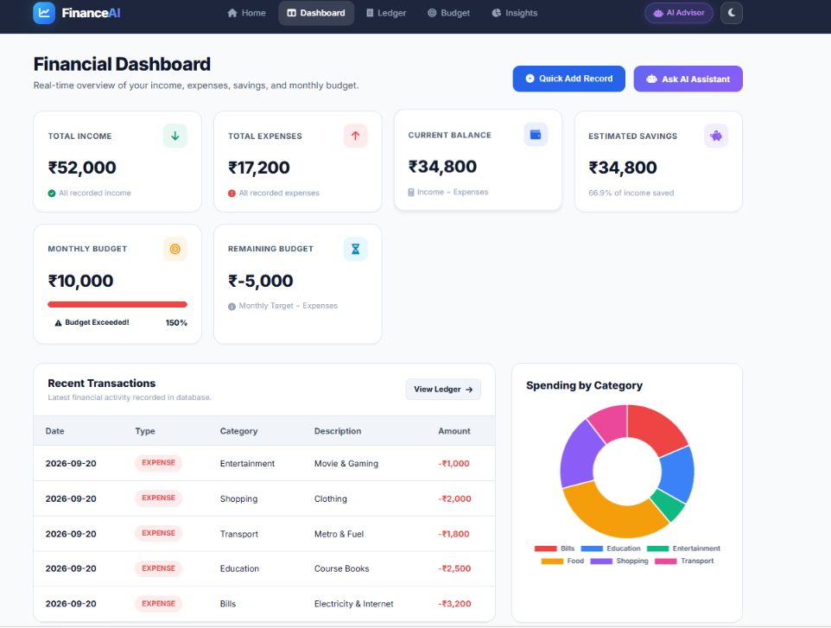
Figure 2: Dashboard

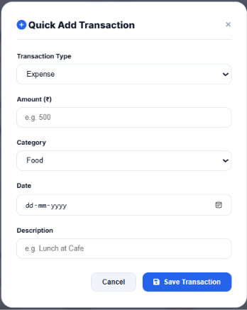
Figure 3: Add Income / Add Expense

10. Web Application Interface (Continued)
The following screenshots show the implemented and working web application.
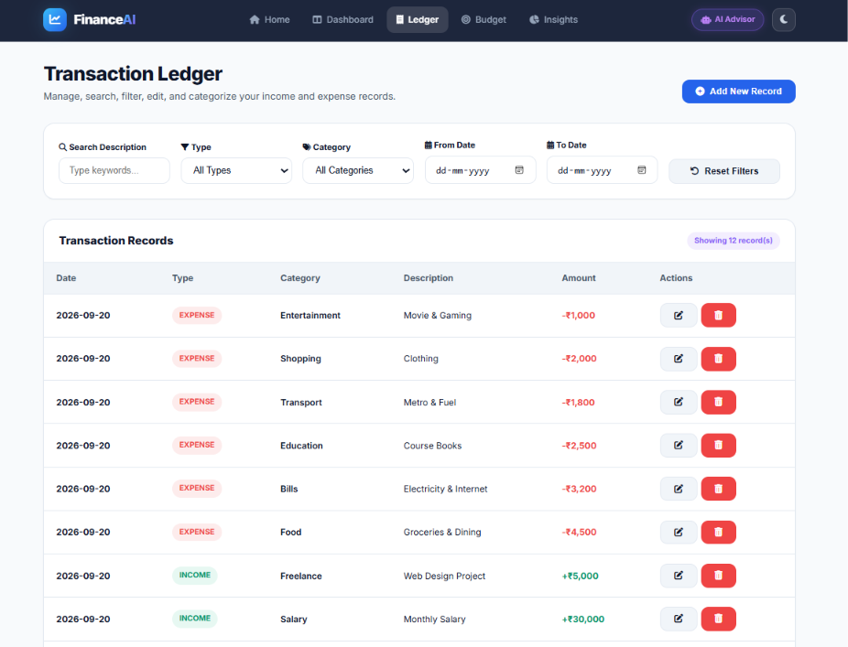
Figure 4: Transactions Page
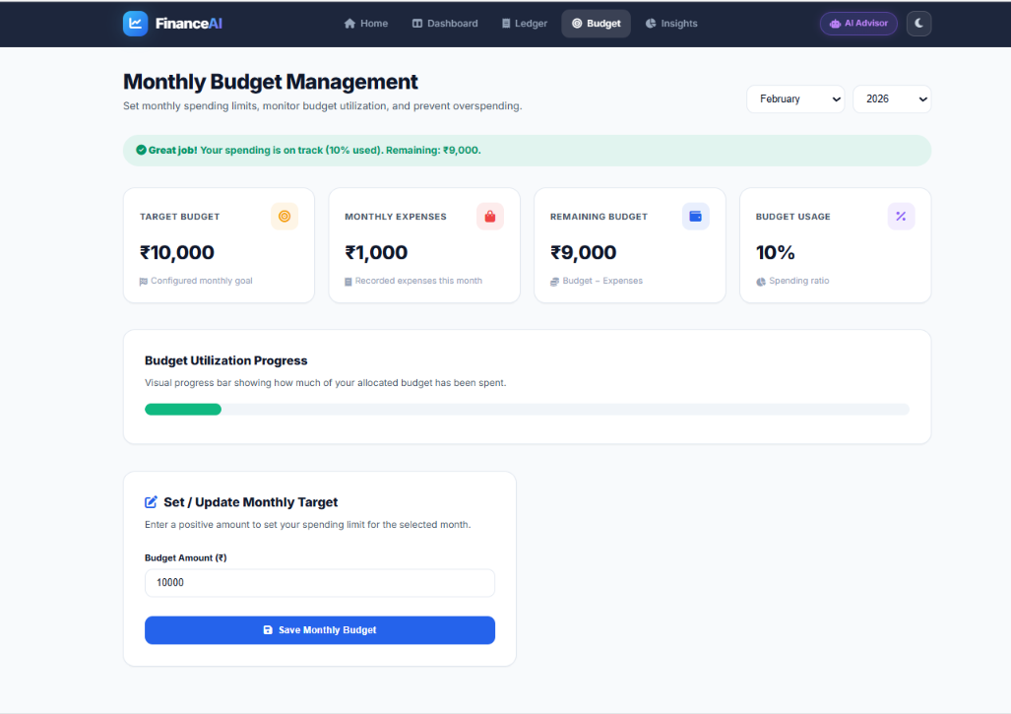
Figure 5: Budget Page
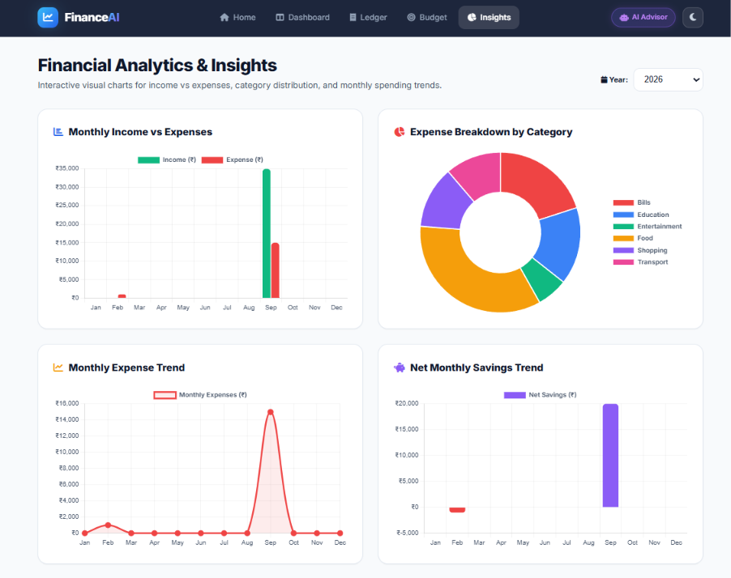
Figure 6: Analytics Page

11. Web Application Interface (Continued)
The following screenshots show the implemented and working web application.
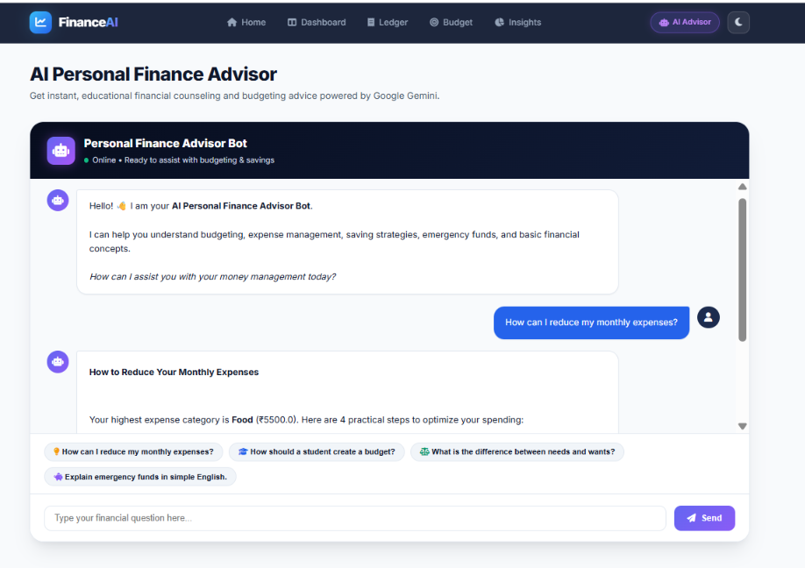
Figure 7: AI Chatbot

12. Testing
The completed application was checked for major user flows and validation conditions.
Test Case | Expected Result | Status
Add income/expense | Record saved and displayed | ✅ Passed
Invalid amount | Validation message shown | ✅ Passed
Edit/Delete transaction | Record updated/removed | ✅ Passed
Budget calculation | Remaining budget calculated | ✅ Passed
Analytics | Charts display stored data | ✅ Passed
AI chatbot | Response displayed to user | ✅ Passed

13. Results
The Personal Finance Advisor Bot was implemented as an interactive web application. Users can record financial transactions, monitor budgets, view analytics and interact with the AI chatbot. The application connects the frontend, Flask backend, database and AI service into one working system.

14. Conclusion
The project provides a simple and practical solution for personal finance management. It combines transaction tracking, budgeting, analytics and AI-based educational guidance in a single responsive web application. The completed system demonstrates the practical use of Python, Flask, SQLite, JavaScript and Gemini AI in a real-world application.

15. Future Scope
User authentication and secure multi-user accounts.
Mobile application version.
Advanced spending prediction and financial reports.
Goal-based savings and reminders.
Additional AI-powered financial insights.

16. References
Python Documentation
Flask Documentation
SQLite Documentation
Chart.js Documentation
Google Gemini API Documentation
--- End of Project Documentation ---

